Assignment 3

Q2.

Derived Activity Durations:

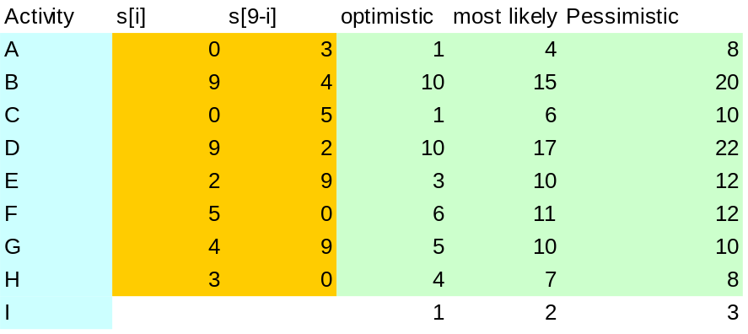

a) Expected duration / Best estimate = (Optimistic + (4*Most Likely) + Pessimistic)/6

A = (1 + (4*4) + 8) / 6 = 4.1666
B = (10 + (4*15) + 20) / 6 = 15
C = (1 + (4*6) + 10) / 6 = 5.8333
D = (10+ (4*17) + 22) / 6 = 16.666
E = (3 (4*10) + 12) / 6 = 9.166
F = (6 (4*11) + 12) / 6 = 10.333
G = (5 + (4*10) + 10) / 6 = 9.166
H = (4 + (4*7) + 8) / 6 = 6.666
I = (1 + (4*2) + 3) / 6 = 2

b) Standard Deviation = (Pessimistic – Optimistic) / 6

A = (8-1) / 6 = 1.666
B = (20-10) / 6 = 1.666
C = (10-1) / 6 = 1.5
D = (22-10) / 6 = 2
E = (12-3) / 6 = 1.5
F = (12-6) / 6 = 1
G = (10-5) / 6 = 0.833
H = (8-4) / 6 = 0.666
I = (3-1) / 6 = 0.333
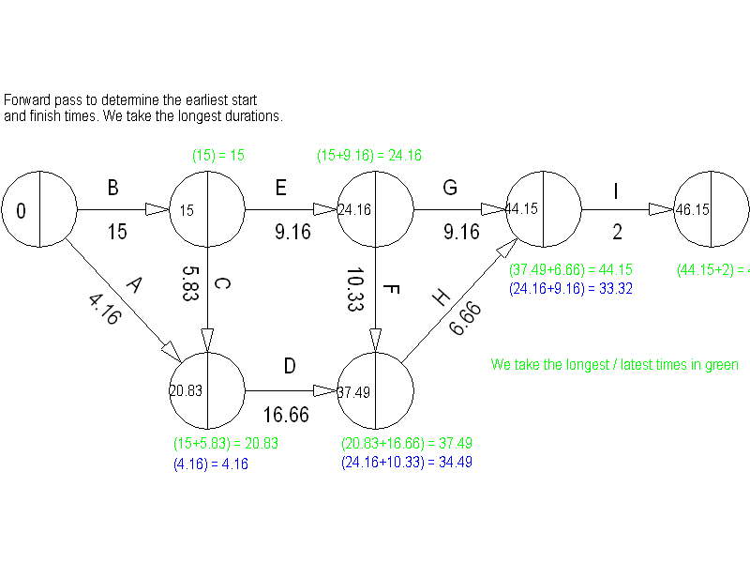
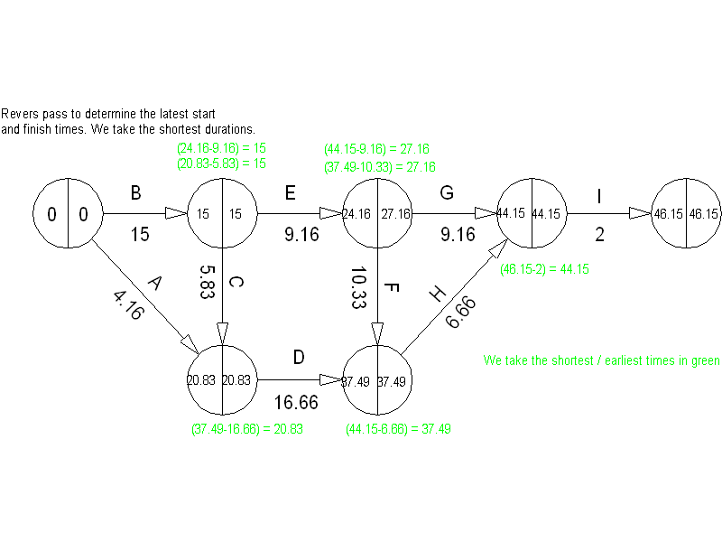

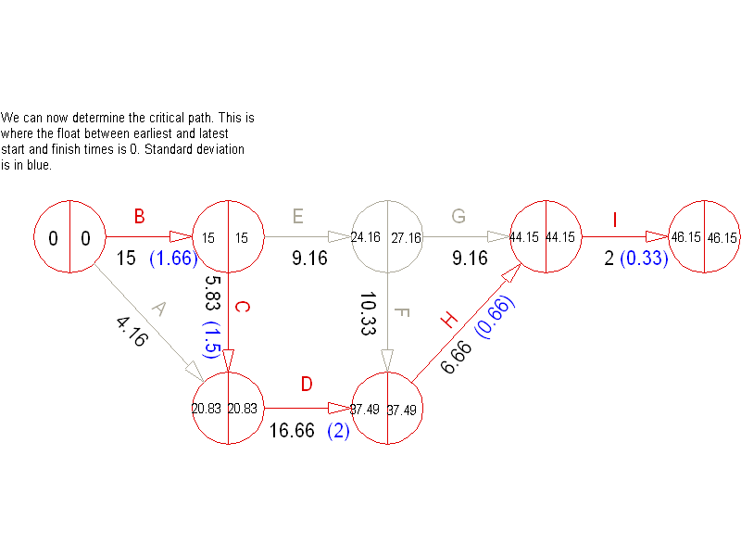
It can be seen above that the critical path is B + C + D + H + I. Therefore the expected duration for the project can be given by the sum of these tasks:
Expected completion time = 15 + 5.83 + 16.66 + 6.66 + 2
= 46.15 days
e) Standard Deviation of critical path = √1.66² + 1.5² + 2² + 0.66² + 0.22²
= 3.095
= 3.10 days

